(Approx. 852 words)

Musings of an Apple Tyro
By Lorrin R. Garson, Potomac Area Technology and Computer Society
July 2016 issue, PATACS Posts
www.patacs.org
newslettercolumnist (at) patacs.org
Protection against Ransomware
Ransomware is malicious software that blocks access to your computer or files, usually by encryption, until money is paid. This type of malevolent software is an increasing threat. Short of paying-up, which is no guarantee of recovery, what can you do if you’re hit with this plight? Of course, the best protection is to prevent infection by properly using anti-malware software and employing good user practices (ignore email from unknown sources, don’t click on unknown or suspicious links, etc.). Even though ransomware may infect your backup files, if you use versioning backup software, you have a reasonable chance to recover from earlier, un-infected backups. I suggest you have two or three backup drives and cycle them every week or two, leaving only the current drive attached to your computer and thus the Internet. In the Apple world, Time Machine provides versioning and there are numerous backup products in the Windows environment such as Acronis True Image 2016, StorageCraft ShadowProtect 5 Desktop, Genie Timeline Home, and NTI Backup Now 6. Windows 10s File History backup can also be useful for this purpose as can some (most?) Cloud storage systems. See http://bit.ly/1sy4MYp and http://bit.ly/1sr6XME.
Dangerous Computer Cords
Do you own a Microsoft Surface Pro, Surface Pro 2 or Surface Pro 3 (2013 through early 2015)? Microsoft is replacing about 2 million power cords for these computers because these cords can overheat and shock or cause a fire. For a free replacement, call 855-327-7780 or go to http://bit.ly/1XzqiaF.
Update to OS X
On May 16th, Apple released an OS X update (from v. 10.11.4 to 10.11.5). This is probably the last release before a major release in October or November. The forthcoming OS, code named Fuji, will likely be revealed at the Worldwide Developer Conference WWDC) on June 13th.
Update to iTunes
As part of the OS X update, Apple released iTunes 12.4 (v. 12.4.0.119). While improvements have been made, iTunes still remains a generally unloved application. Initial reviews are tepid. See http://bit.ly/1rTF9Rn.
Fastest Internet Speed
What country would you think has the fastest Internet speed? It isn’t the U.S.— it’s Singapore. This shouldn’t be a surprise because Singapore is a very small, rich country. So we’re number two, right? Nope. Table 1 below shows the 10 countries with the fastest average peak connection speed (from http://til.ink/1TYolik).
The U.S. is number 24, with an average peak connection speed of 50.4 Mbps, after Bulgaria (51.0 Mbps) and the United Kingdom (50.9 Mbps). Other reports show the U.S. at number 15 (see http://ti.me/23X7aDd) and number 21 (http://bit.ly/1WDYsuu). For detailed information see http://akamai.me/205LeoB.

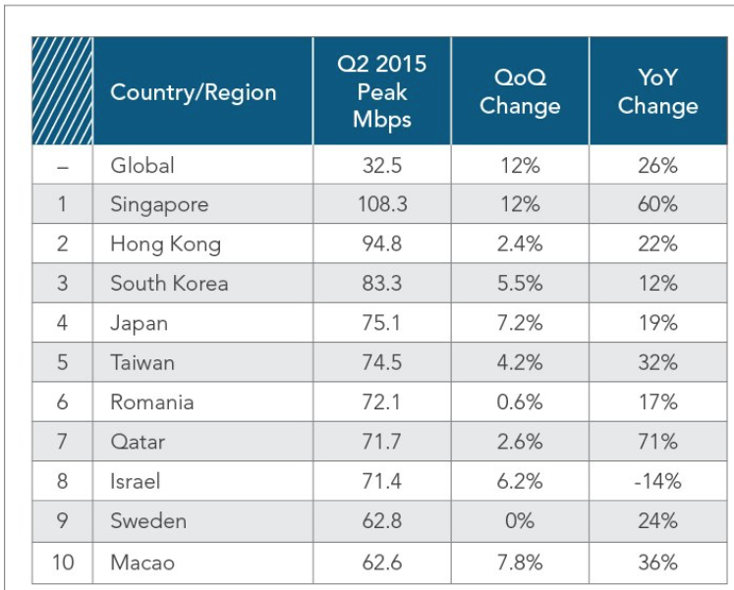
Table 1
Adobe Flash Player
Because of the security risks of Flash Player, you may want to frequently check for updates. I suggest a weekly check. Also, this is one piece of software you may want to set for automatic updates. For Windows-based computers, search Google for “how to check for updates for flash player win” and pick the appropriate version of the operating system. Windows 10 users may find http://bit.ly/1rTGV50 of value. For those using Mac computers, do the following: System Preferences ➔ Flash Player ➔ Updates ➔ Check Now ➔ follow directions presented.
See http://bit.ly/1OHNv8F for a good description of Flash Player.
An AI Rembrandt Painting
A deep-learning algorithm, coupled with a 3D printer, has produced a new “Rembrandt” painting that is remarkably like something the Dutch master would produce (see Figure 1).


Figure 1
The computer-based painting is based on computer analysis of 346 known Rembrandt paintings. The “painting” was created with a 3D printer using special paint-based UV ink with 13 layers of ink—148 million pixels. See http://bit.ly/1TjIhgb for an explanation. See https://www.nextrembrandt.com for a video describing the project.
Aging Mac Pro
It’s hard to believe that the Mac Pro is aging, but it was introduced in 2013 and now it is competing with Windows desk top machines from Lenovo, Dell and HP that are superior. The Mac Pro is for the professional computing market where users often require very substantial compute power and often demand the latest and greatest. See http://bit.ly/1rTIS1d.
Amazon Top Provider of Cloud Services
Most of us think of Amazon as the online store that seemingly sells everything imaginable. However, it is by far the largest provider of Cloud services having ten times the computing capacity than the next 14 largest Cloud companies combined. Amazon’s Cloud is generally used by large corporations, but individuals can also use their services. Amazon Prime Members ($99/year) can store an unlimited number of photos, videos and files at no extra cost. Not a Prime Member? You can rent 5 GB of storage for $11.99/year or unlimited storage for $59.99/year. See pricing at https://www.amazon.com/clouddrive/home. Also see http://for.tn/1TjKqs1 and http://bit.ly/1qtD4tP.

